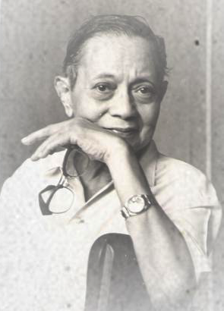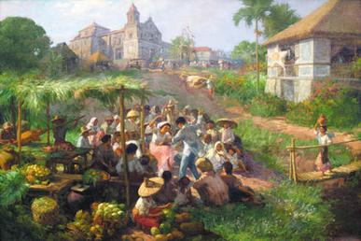

Fernando Cueto Amorsolo:
Antipolo by Fernando Amorsolo, depicting Filipinos celebrating the annual pilgrimage to Antipolo, with the pre-War cathedral depicted in the background.

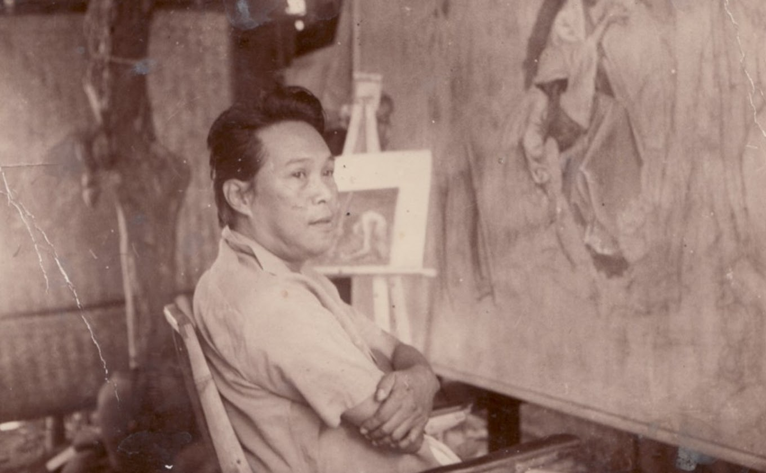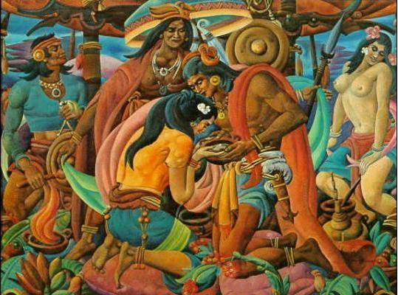

Carlos Modesto "Botong" Villaluz Francisco:
His great works include portrayals of the Blood Compact, First Mass at Limasawa, The Martyrdom of Rizal, Bayanihan, Magpupukot, Fiesta, Bayanihan sa Bukid, Sandugo, Portrait of Purita, The Invasion of Limahong, Serenade, and Muslim Betrothal.

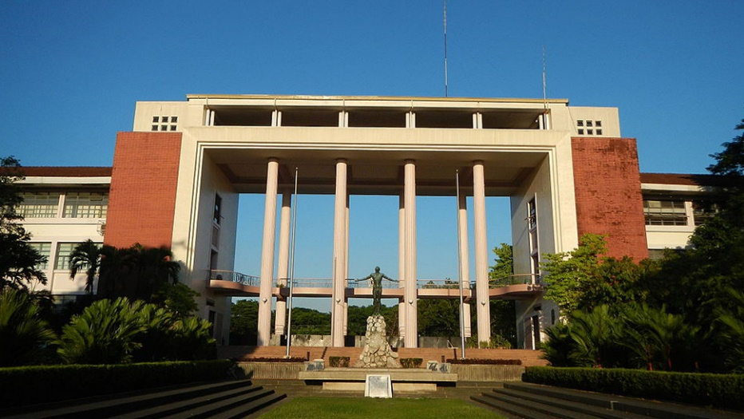
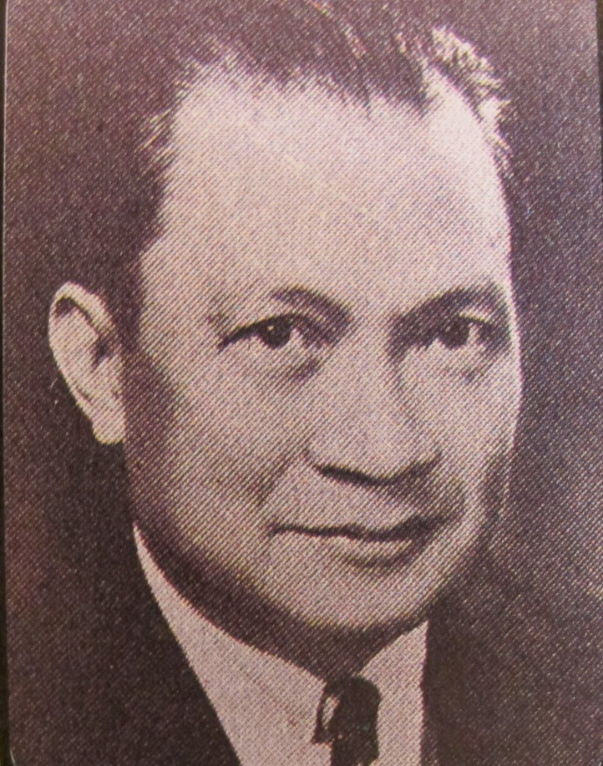
Juan Felipe De Jesus Nakpil
Also known as Juan Nakpil, was a Filipino architect, teacher and a community leader. In 1973, he was named one of the National Artists for architecture

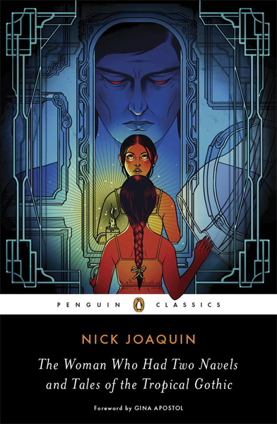
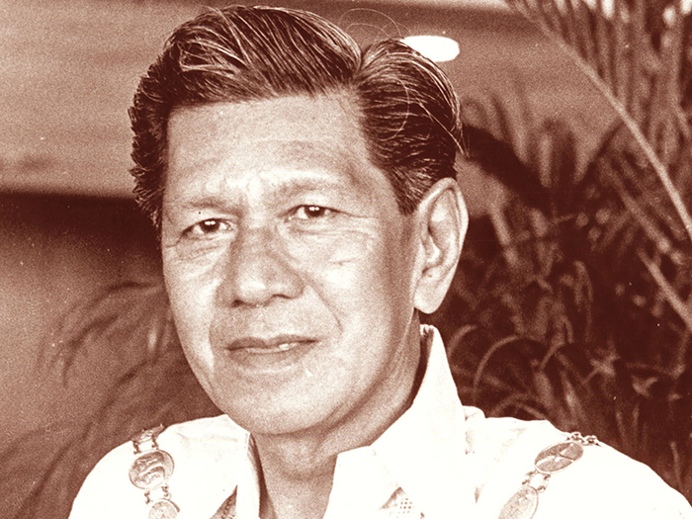
Nicomedes “Nick” Joaquin y Marquez:
He was a Filipino writer and journalist best known for his short stories and novels in the English language.

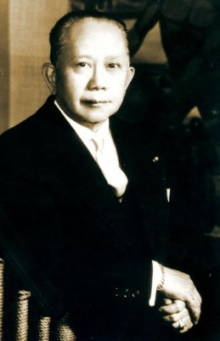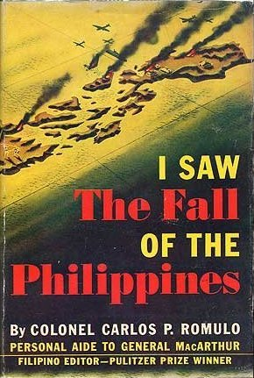
Carlos P. Romulo:
He was a Filipino diplomat, statesman, soldier, journalist and author. He was a reporter at 16, a newspaper editor by the age of 20, and a publisher at 32.

