Loreto, Jan Laurence B.
BPE 3A
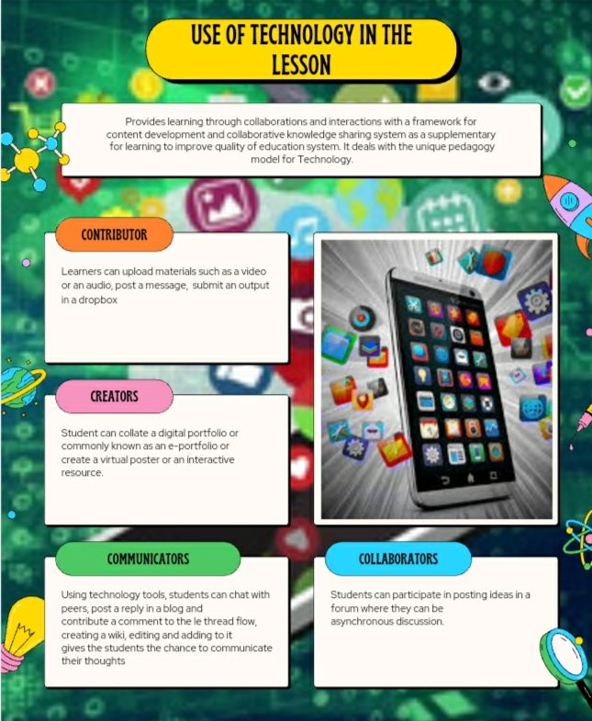
Essay Writing:

Technology is the primary medium for making different activities for better results. Technology trends can encourage the learners to engage in class discussion. Technology seems to be the "must" in this generation. In order to : make a class presentation; video introduction; a visual for discussion; creating written works; and to enhance performance task, you must use technology. If without technology, an individual works hard in order to complete a minimal amount of task in a long time but with technology it's not like that. Technology makes everything better than before.
Technology is important in eduction because nowadays education revolves around technology. It improves the quality of education. It changes the traditional learning into interactive learning. It helps every student to become more competitive and create better experience for every students. It is convenient to every students and teachers that they could save time, effort and money.
In using technology education, improve performance, enhance presentation and better results are being emphasize. It covers the different areas of education. Not only in discussion or performance but also in communication and consulting for things that could fulfill the undone schoolworks.

