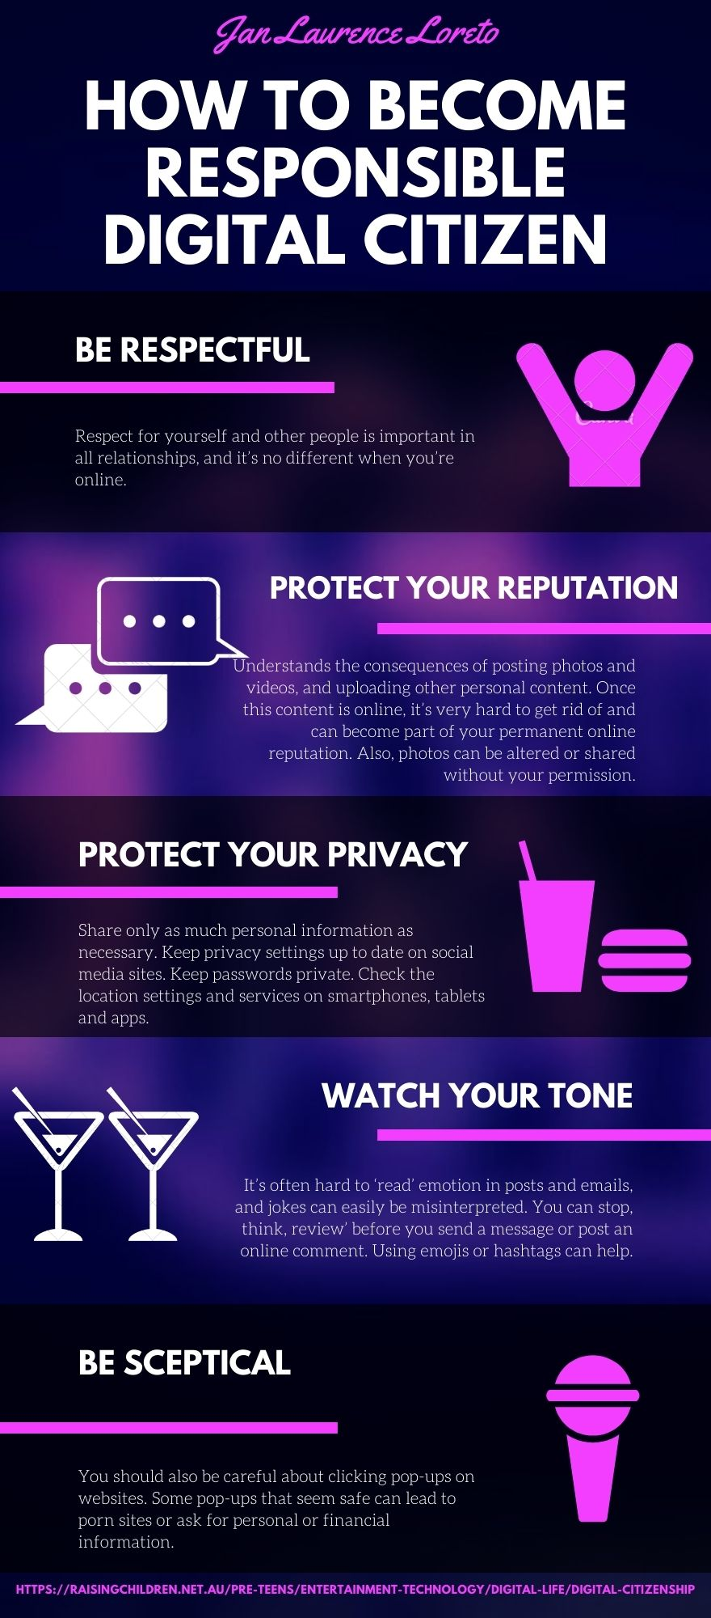
Essay Writing: Why should students need to become global digital citizens?

Technology inspires youth to become more lively and aware about everything. Netizen are exchanging information to the other netizen. It is like "one for all and all for one" that have been created by the internet that connects eveyone in online platform. Every individual should be accountable for deciding what information to choose and what information to avoid.
Digital literacy, media literacy, and social literacy are all skills that netizens should have. Students should know how to properly cite every article, as well as how to paraphrase and avoid plagiarism. They should also know how to write articles, post their own work, and approach others appropriately. These items will most likely assist kids in becoming global digital citizens.
It is important that students become an individual who, in all of their online and offline contacts, responsibilities, and endeavors, attempts to create a sense of global community. It may be beneficial to students to be more productive in terms of the things they may create and share online or offline using various technologies.

